**Prolim Training Software installation steps**

**Machine / Hardware requirement**

1. Window OS 10/11 Version
2. RAM 16/32 GB Ram
3. Chrome browser

**Software installation**

**Install Git on Windows**

**🔹 Step 1: Download Git**

* Go to the official Git website:  
  👉 <https://git-scm.com/downloads>
* Click on **"Windows"** to download the Git installer (usually named like Git-<version>-64-bit.exe)

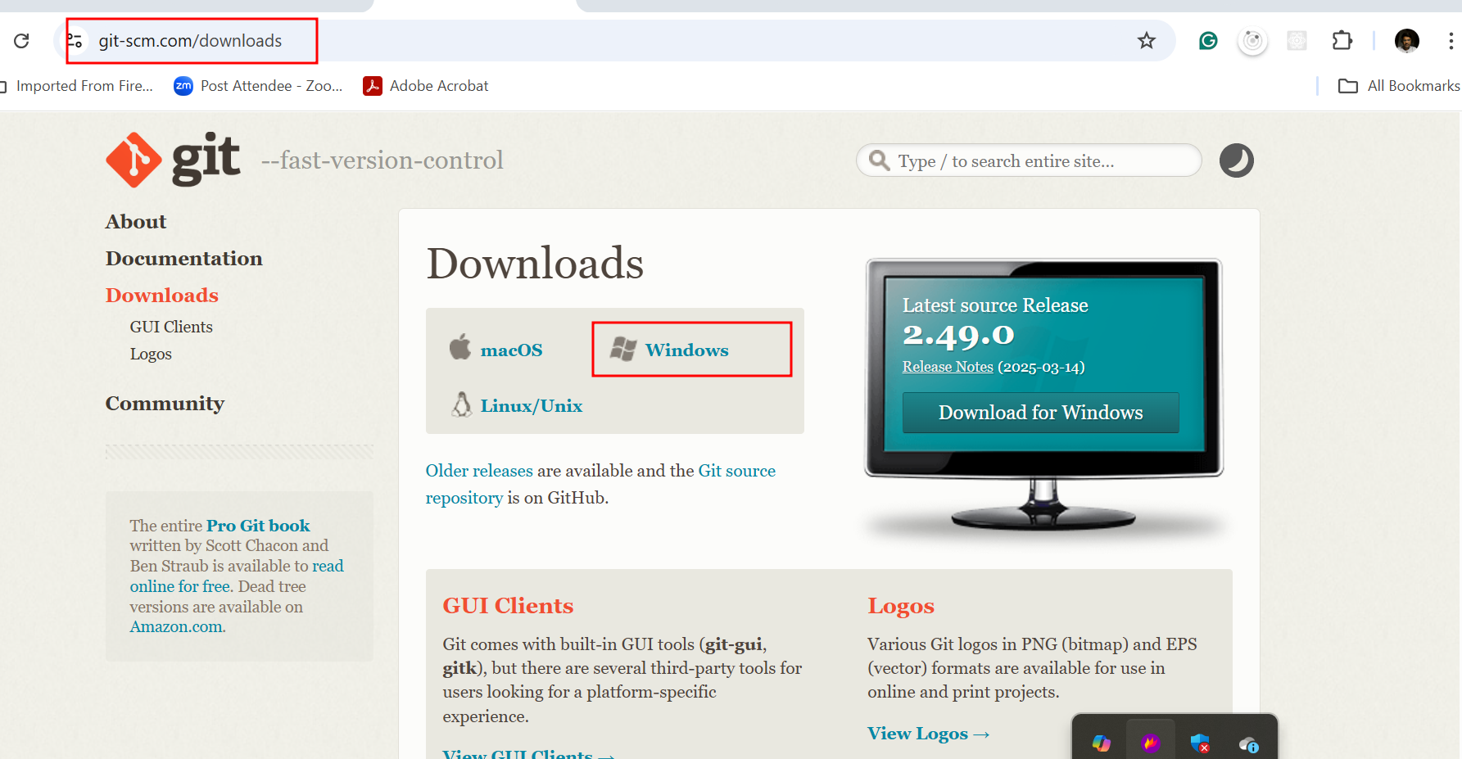

**Step 2: Run the Installer**

1. **Double-click** the downloaded .exe file.
2. Click **"Next"** on the Welcome screen.

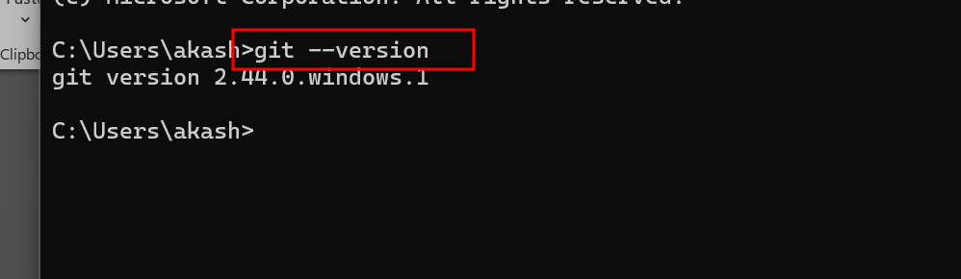

Version can different doesn’t matter.

**(Optional) Configure Git**

After installing, configure your name and email globally:

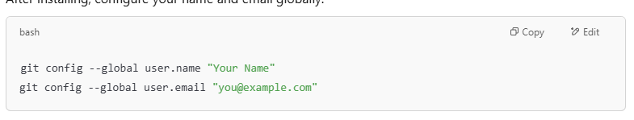

**Java 17 Installation on Windows**

**🔹 Step 1: Download Java 17**

You can download Java 17 from any of the following trusted sources:

**✅ Oracle JDK 17 (Recommended)**

* Go to: <https://www.oracle.com/java/technologies/javase/jdk17-archive-downloads.html>
* Choose: Windows x64 Installer (.exe file)

**Step 2: Install Java 17**

1. Run the downloaded .exe installer.
2. Follow the wizard:
   * Accept license agreement.
   * Choose the destination folder (e.g., C:\Program Files\Java\jdk-17)
   * Complete the installation.

**Step 3: Set Environment Variables**

**➤ 1. Set JAVA_HOME**

* Press Win + S, type **Environment Variables**, and select **Edit system environment variables**.
* In the **System Properties** window, click **Environment Variables**.
* Under **System variables**, click **New**:
  + **Variable name**: JAVA_HOME
  + **Variable value**: C:\Program Files\Java\jdk-17

**➤ 2. Add JAVA_HOME\bin to PATH**

* In **System variables**, find and select the Path variable, then click **Edit**.
* Click **New**, and enter:

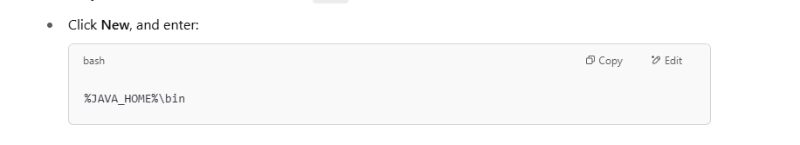

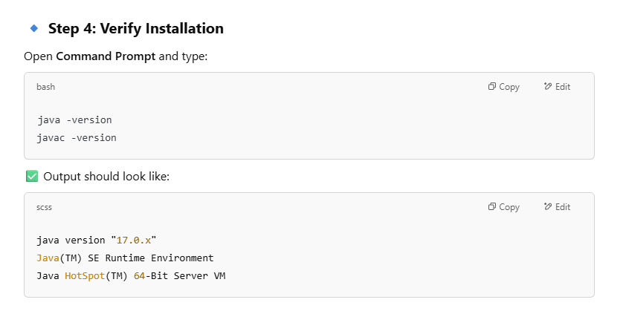

**Download Apache Maven**

* Go to the official download page:  
  👉 <https://maven.apache.org/download.cgi>
* Click on the latest **Binary zip archive** under **Files**. Example:



**Step 2: Extract Maven**

1. Extract the .zip file to a preferred location (e.g.):

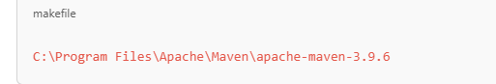

1. Copy the path of the apache-maven-3.9.6 folder.

**Step 3: Set Environment Variables**

**➤ 1. Set MAVEN_HOME**

* Open **Environment Variables**:
  + Press Win + S → Type **environment variables** → Click **Edit the system environment variables**
* Under **System Variables**, click **New**:
  + **Variable name**: MAVEN_HOME
  + **Variable value**: C:\Program Files\Apache\Maven\apache-maven-3.9.6

**➤ 2. Add to Path variable**

* In the same window, find the Path variable and click **Edit**.
* Click **New** and add:

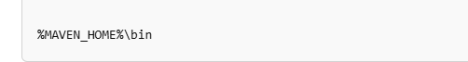

**Step 4: Verify Maven Installation**

Open **Command Prompt** and run:



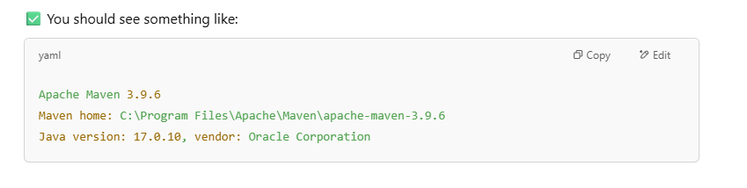

**MySQL Installation**

**Step 1: Download MySQL Installer**

Go to the official MySQL website:  
👉 <https://dev.mysql.com/downloads/installer/>

* Choose **MySQL Installer for Windows**
  + Download the **"MySQL Installer (Community)" – Full version (~400MB)**

**Step 2: Run the Installer**

1. Double-click the downloaded .msi file.
2. Choose:
   * ✅ **Developer Default** *(Recommended)*  
     Installs MySQL Server, MySQL Workbench, MySQL Shell, and connectors.

**Step 3: Install Required Software**

The installer may prompt to install required components like Visual C++ Redistributable. Click **Yes** to proceed.

**Step 4: MySQL Server Configuration**

Follow these steps in the setup wizard:

**➤ 1. Type and Networking**

* Configuration Type: **Standalone MySQL Server**
* Connectivity: Leave default TCP/IP Port 3306

**➤ 2. Authentication Method**

* Choose: **Use Strong Password Encryption for Authentication (RECOMMENDED)**

**➤ 3. MySQL Root Password**

* Set a strong root password
* Optionally, add a new MySQL user with limited privileges

**➤ 4. Windows Service**

* Leave as default:
  + Run as Windows Service
  + Start MySQL Server at system startup

**🔹 Step 5: Complete Installation**

1. Apply the configuration
2. MySQL Server will start
3. Click **Finish**

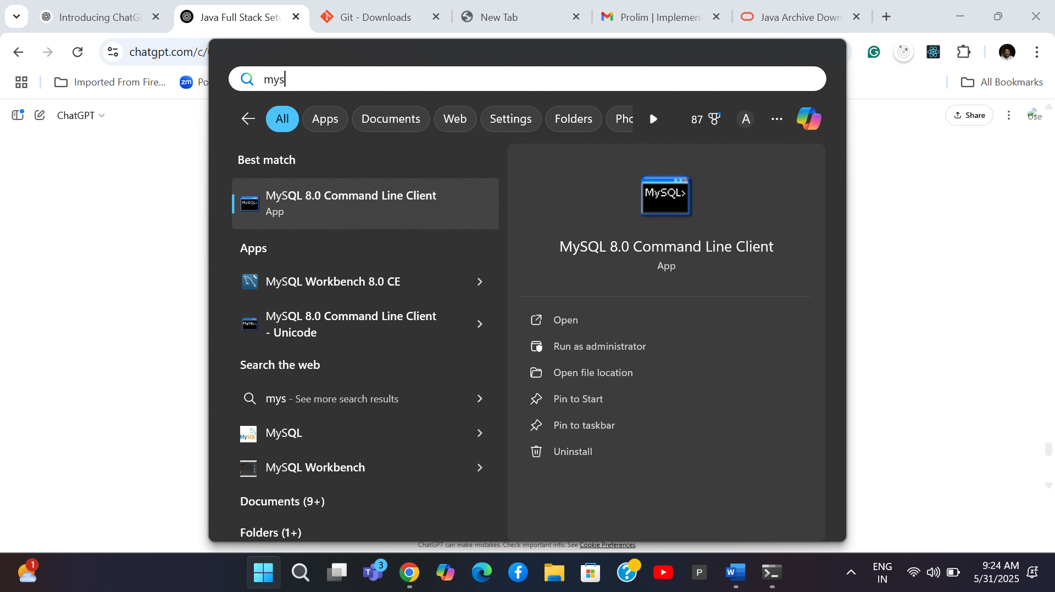

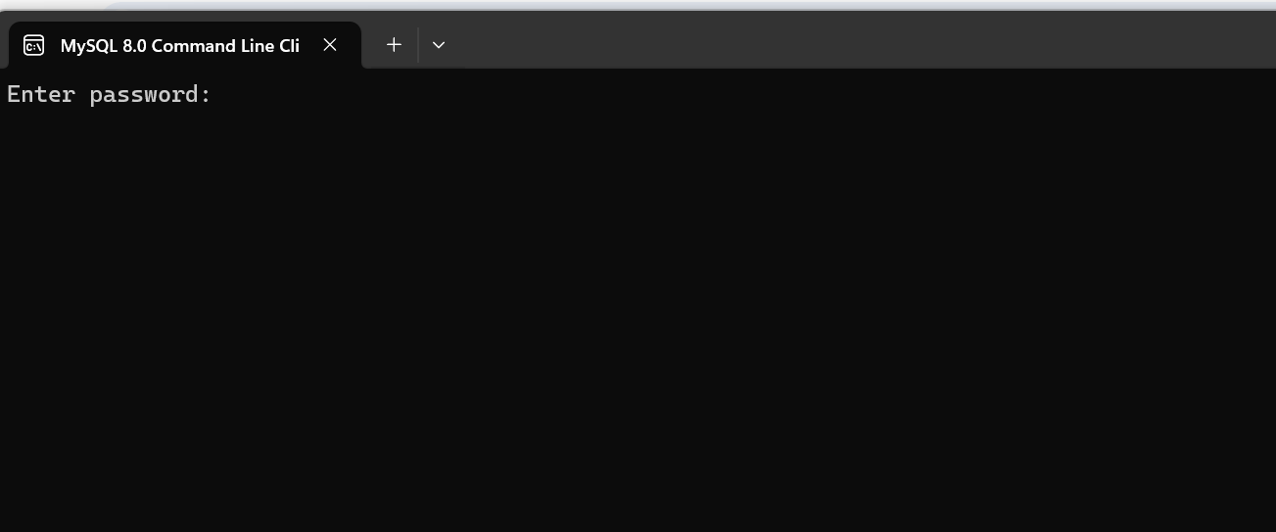

Please provide your database password

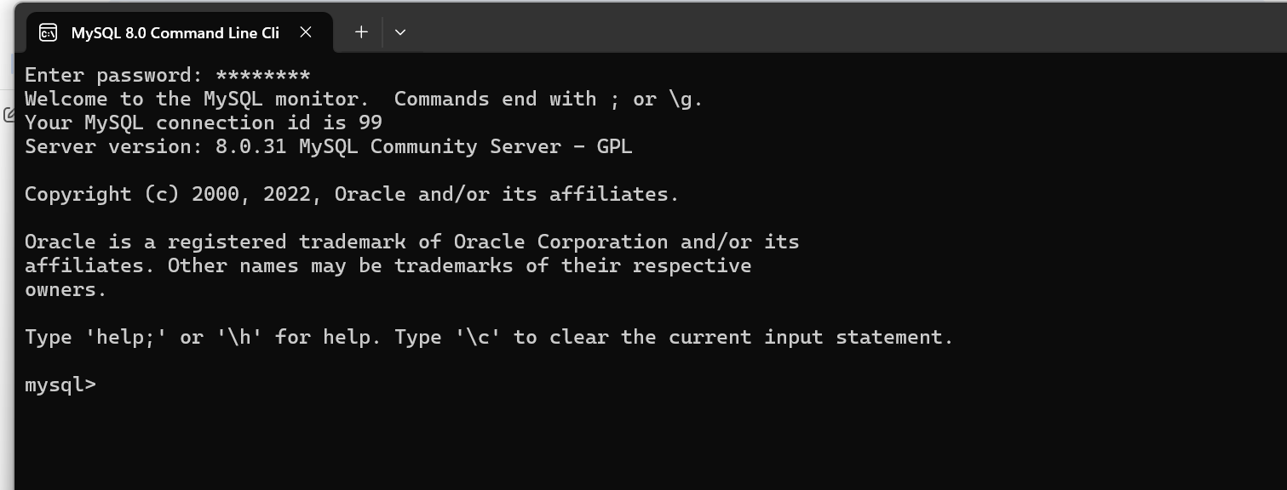

**Download the Eclipse IDE**

**Step 2: Download Eclipse IDE**

* Go to the official website:  
  👉 <https://www.eclipse.org/downloads/packages/>

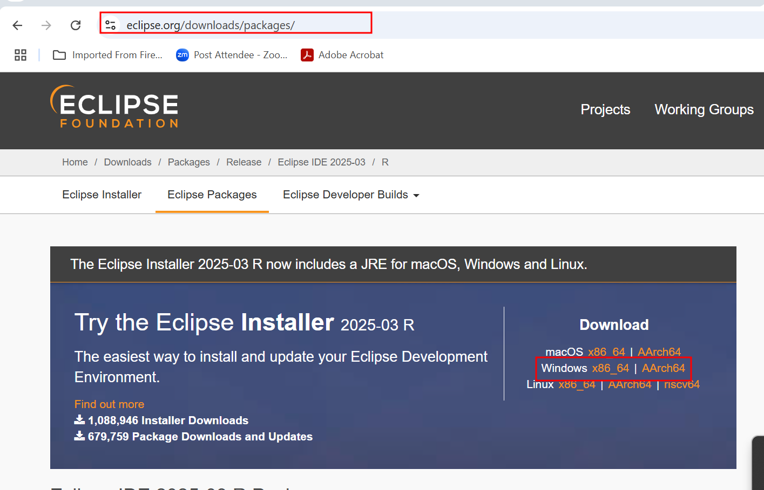

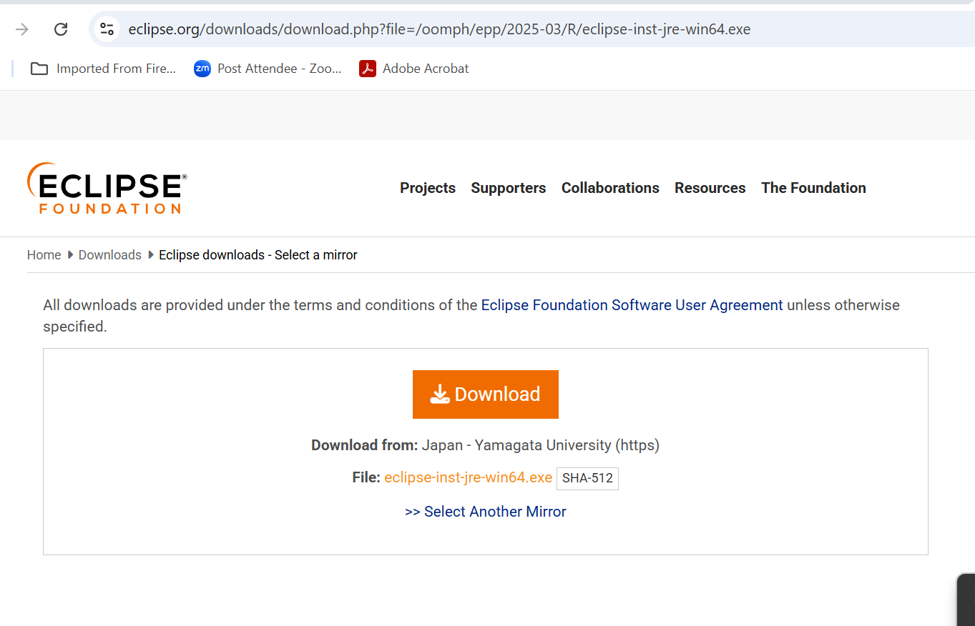

In Eclipse installer you need to search eclipse for JEE and then install that IDE.

**Install VS Code on Windows**

**🔹 Step 1: Download VS Code**

* Visit:  
  👉 <https://code.visualstudio.com/>
* Click the **Download for Windows** button  
  (This will download the .exe installer)

**Step 2: Run the Installer**

1. Double-click VSCodeUserSetup-x64-x.x.x.exe
2. Accept the license agreement → **Next**
3. Choose the installation location (default is fine) → **Next**
4. **Select Additional Tasks**:  
   ✅ Recommended:
   * Add to PATH
   * Add "Open with Code" to Windows Explorer
   * Register Code as editor for supported file types
5. Click **Install**
6. Click **Finish** (Optionally launch VS Code immediately)

**Step 3: Launch and Customize**

* Start VS Code from the Start Menu or desktop
* Interface will open with Welcome screen

**Install Node.js on Windows**

**🔹 Step 1: Download Node.js**

* Visit the official Node.js site:  
  👉 <https://nodejs.org/>
* You’ll see two options:
  + **LTS (Recommended)** – Long-Term Support (stable)
  + **Current** – Latest features, not always stable

✅ Choose **LTS version** (e.g., Node.js 20.x.x LTS)

**🔹 Step 2: Run the Installer**

1. Download the .msi file
2. Double-click the file to start installation
3. Follow the wizard:
   * Accept license agreement
   * Choose destination folder (default is fine)
   * Keep default options ✅
   * Ensure **"Add to PATH"** is checked
4. Click **Install**
5. Once done, click **Finish**

**🔹 Step 3: Verify Installation**

Open **Command Prompt (CMD)** or **PowerShell** and type:

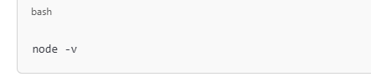

**You should see the Node.js version (e.g., v20.11.0)**



**You should see the npm (Node Package Manager) version (e.g., 10.2.4)**

**Installation of docker**

**Step 1: System Requirements**

**✅ Prerequisites:**

* Windows 10 64-bit: Pro, Enterprise, or Education (Build 19044 or higher)
* OR Windows 11 (any edition)
* Hardware Virtualization must be enabled in BIOS
* WSL 2 (Windows Subsystem for Linux) for Windows Home

**Step 2: Download Docker Desktop**

Go to the official Docker website: **👉** [**https://www.docker.com/products/docker-desktop/**](https://www.docker.com/products/docker-desktop/)

* Click Download for Windows (Intel/AMD chip)

**Step 3: Install Docker Desktop**

1. Run the downloaded installer .exe
2. In the setup wizard:
   * Check the boxes for:
     + Enable WSL 2 Windows Features
     + Add shortcut to Desktop (optional)
   * Click OK to install
3. If not already installed, Docker will download & install WSL 2 backend and Ubuntu distro
4. Follow the prompts and allow system reboots if needed

**Step 4: Start Docker Desktop**

* After installation, Docker Desktop starts automatically
* You’ll see the whale icon in the system tray

✅ Wait until it says:  
"Docker Desktop is running"

**Step 5: Verify Docker Installation**

Open Command Prompt or PowerShell and run:

**docker --version**

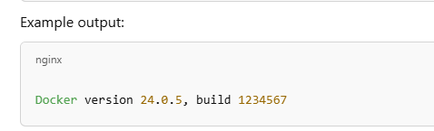

**To test Docker with a container:**

